**CHICAGO CRIME DATA ANALYSIS**

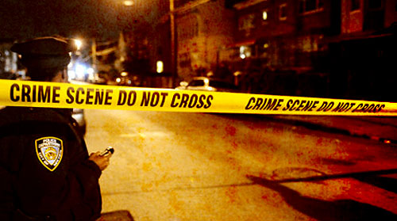

**Group 3: -**

Deepti Khatri

Preethi Kannan

Rakesh Jain

Sanket Bhaud

Contents

**ABSTRACT** 3

PROBLEM 3

METHODS USED 3

RESULTS OBTAINED 3

**MATERIALS AND METHODS** 3

DATASET DESCRIPTION 3

**TOOLS AND TECHNIQUES** 4

DATA PRE-PROCESSING 4

EXPLORATORY ANALYSIS 5

PREDICITVE MODELLING 5

TOOLS USED 5

**RESULTS AND DISCUSSION** 6

RESULTS 6

DISCUSSION 17

**LIMITATIONS** 18

**FUTURE SCOPE** 18

**BUSINESS OBJECTIVE ACCOMPLISHED** 18

**REFERENCES** 18

**ABSTRACT**

PROBLEM

There has an abundance of crimes committed on a daily basis in Chicago, one of the most populated states in the United States. In this project, we use Chicago Crime dataset which reflects reported incidents of crime that occurred in the City of Chicago from 2012 to 2016. Our goal is to help the Chicago police department and local public by identifying the most occurring crimes, observe the trend over the years, and find the highly prone crime areas.

METHODS USED

The methods used focus on cleaning the data followed by preliminary analysis, comprising temporal and spatial analysis. Also, the data contains mostly categorical variables, so multi class classification techniques are used for predictive modelling which predicts the crime type.

RESULTS OBTAINED

Our analysis mainly focuses on temporal and spatial visualization along with finding a suitable model to predict the primary crime type.

**MATERIALS AND METHODS**

DATASET DESCRIPTION

1. unique_id: - Unique identifier for the record.
2. date: - Date when the incident occurred. this is sometimes a best estimate.
3. primary_type: - The primary description of the IUCR code.
4. description: - The secondary description of the IUCR code, a subcategory of the primary description.
5. loc_desc: - Description of the location where the incident occurred.
6. arrest: - Indicates whether an arrest was made.
7. beat: - Indicates the beat where the incident occurred. A beat is the smallest police geographic area – each beat has a dedicated police beat car. Three to five beats make up a police sector, and three sectors make up a police district. The Chicago Police Department has 22 police districts.
8. district: - Indicates the police district where the incident occurred.
9. ward: - The ward (City Council district) where the incident occurred.
10. community_area: - Indicates the community area where the incident occurred. Chicago has 77 community areas.
11. year: - Year the incident occurred.
12. latitude: - The latitude of the location where the incident occurred.
13. longitude: - The longitude of the location where the incident occurred.
14. location: - The location where the incident occurred in a format that allows for creation of maps and other geographic operations on this data portal.

**TOOLS AND TECHNIQUES**

The methods used to build the model are based on predictive modelling and exploratory analysis.

DATA PRE-PROCESSING

The Steps used for data pre-processing are as follows: -

* Removed 2017 data since it was incomplete.
* Feature Extraction: Date column categorised into morning, afternoon, evening and night.
* Feature Grouping: Crimes types into crime categories.
* Removed missing values from latitude and longitude columns.
* Dropped unused levels from Primary Type
* Categorized crimes into Violence and Non - Violence and location description by using “%n%” method.
* Using POSIX function to transform the datetime into standard format

EXPLORATORY ANALYSIS

* Performed Spatial analysis using Leaflet to visualize crime hotspots and its data on interactive maps.
* Temporal analysis was performed to see the crime patterns through the day using plots and graphs.

PREDICITVE MODELLING

Based on the preliminary findings, the problem reduced to a classification problem to predict the primary crime type. The various methods we used for predictive modelling are Multinomial Logistic Regression, Random Forest and Support Vector Machines.

TOOLS USED

R and Tableau***.***

**RESULTS AND DISCUSSION**

RESULTS

Following are the snapshots of the stories for data exploration**: -**

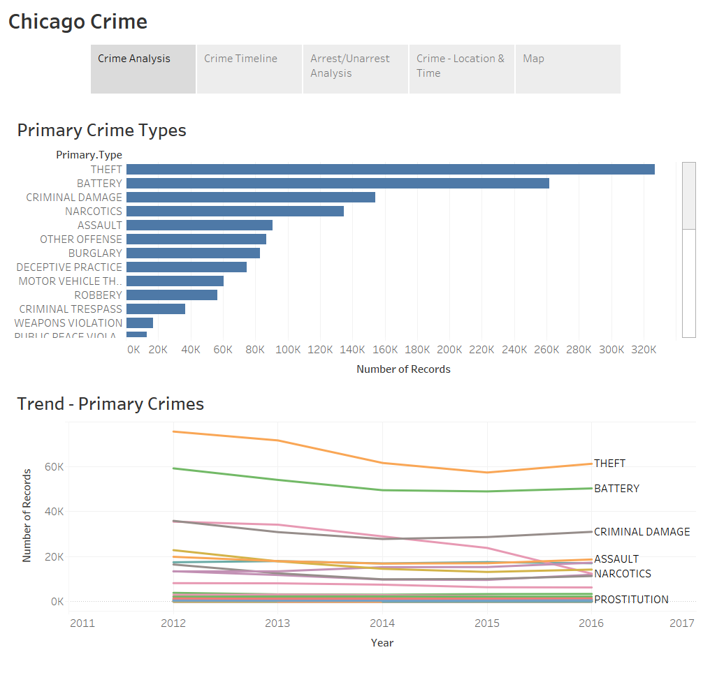

* It shows crime rate of theft, battery, criminal damage, assault and narcotics are highest in Chicago.

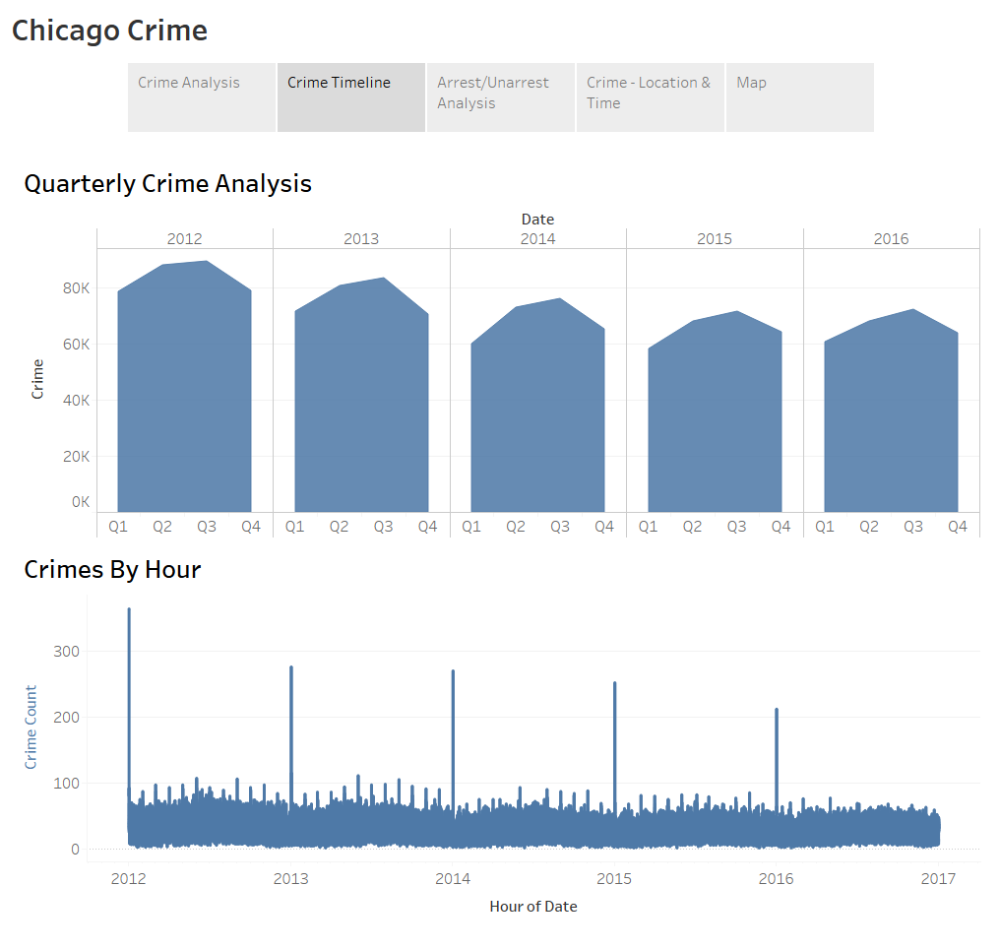

* Most crimes happens in Quarter 2 and 3, that is when weather is good, in summer and fall. Criminal have more chances of hurting people.
* Crimes by hour plot shows that, every new year i.e. Jan 1, 1 AM crimes are at its peak.

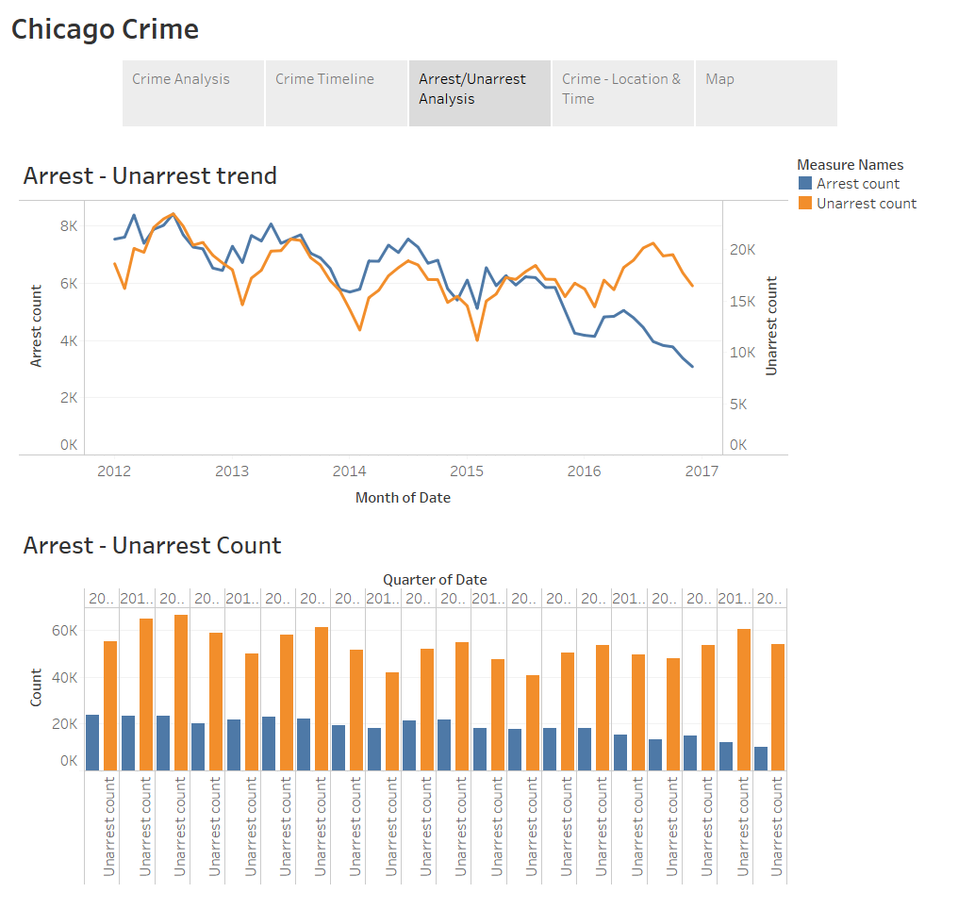

* Unarrest count is higher than the arrest count, police department needs to take serious action to arrest the criminals, as we can see unarrest count is decreasing in year 2016.

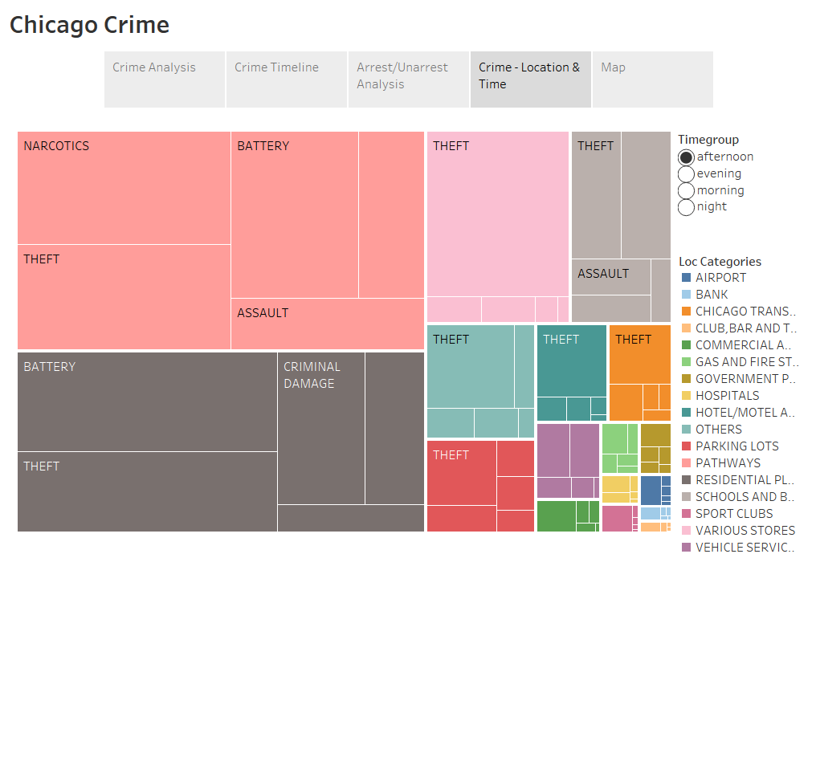

* Plot shows crime and its location every afternoon. During afternoon most crimes happens on pathways.

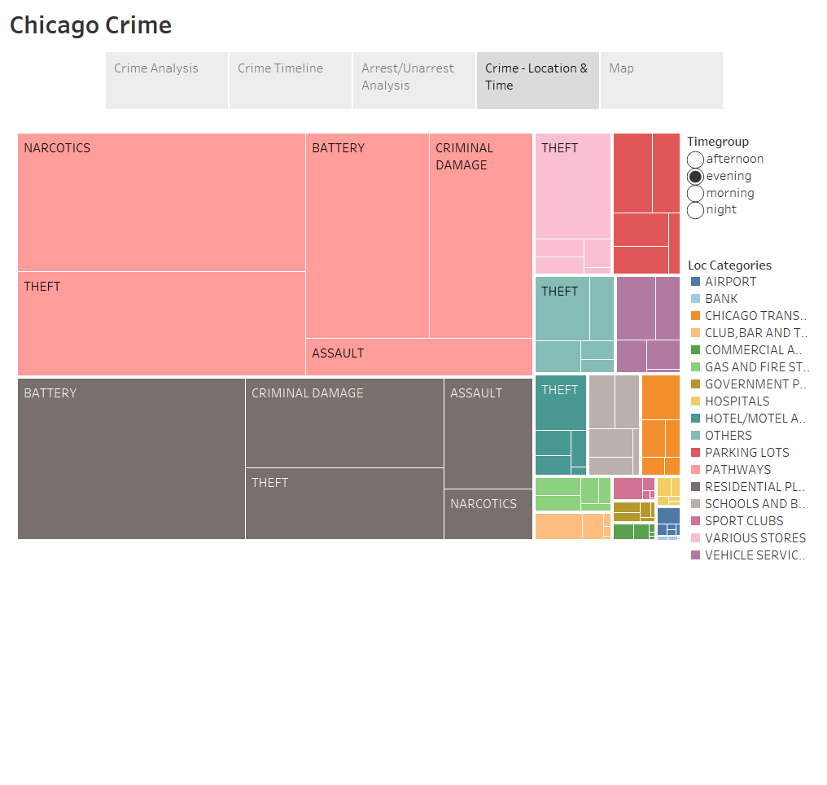

* Plot shows crime and its location every evening. During evening most crimes happens on pathways.

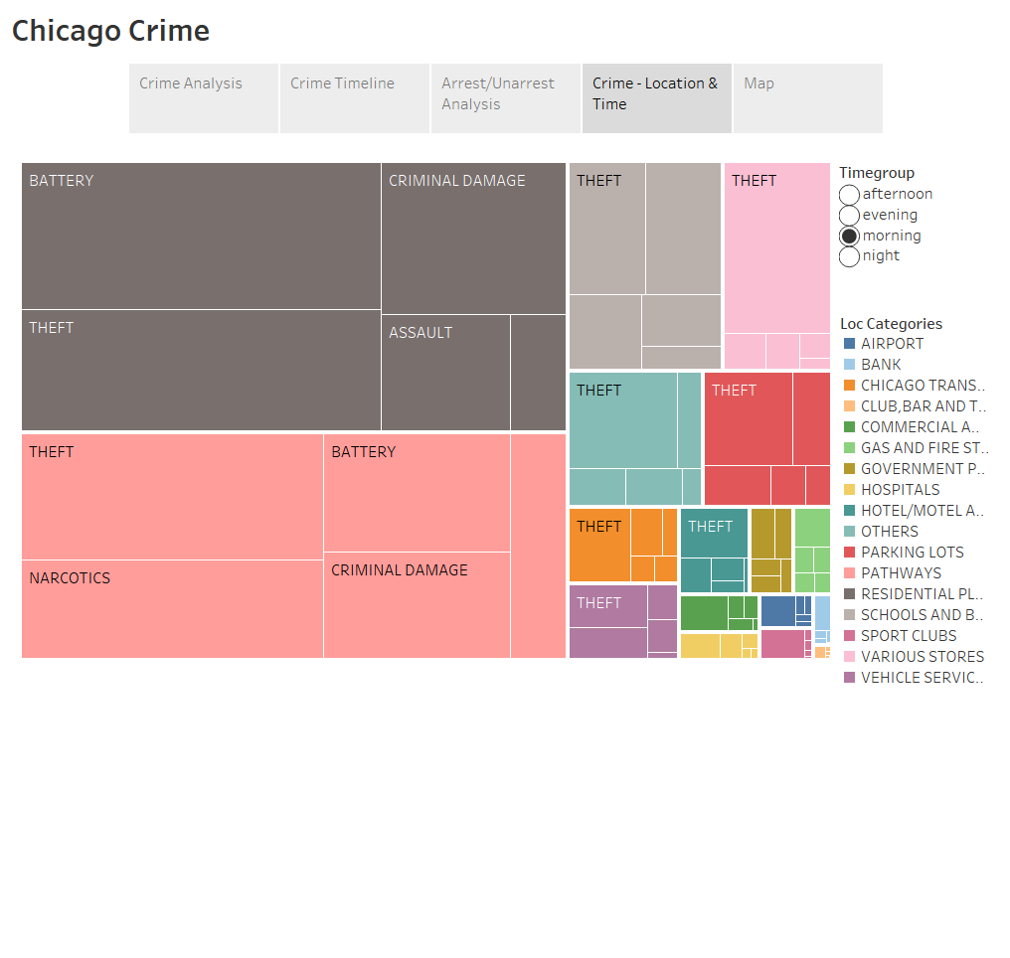

* Plot shows crime and its location every morning. During morning most crimes happens in Residential places.

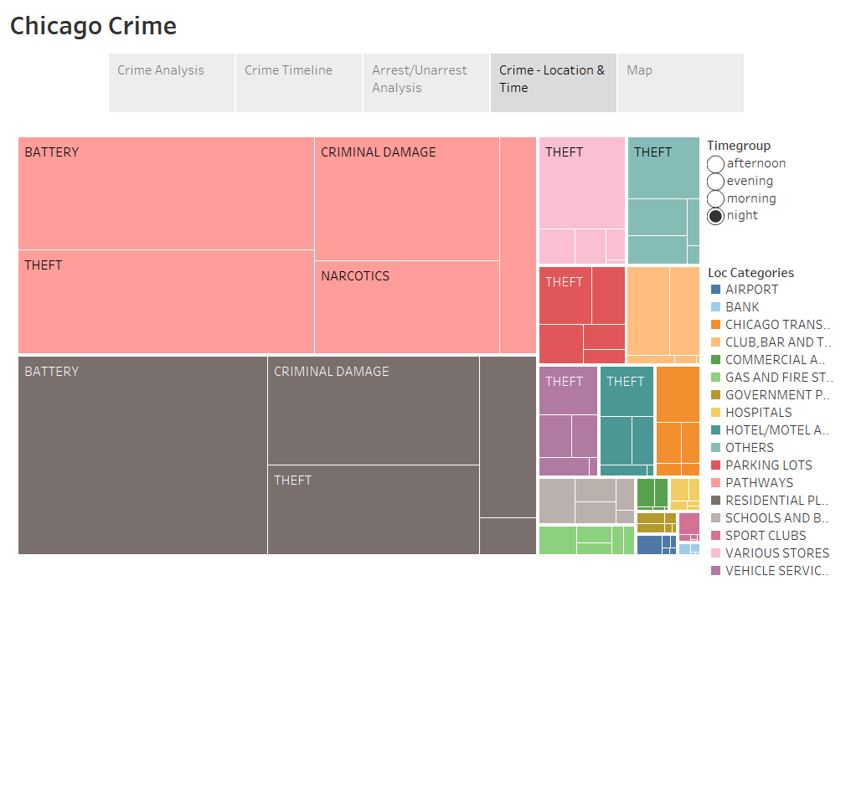

* Plot shows crime and its location every night. During night most crimes happens on pathways.

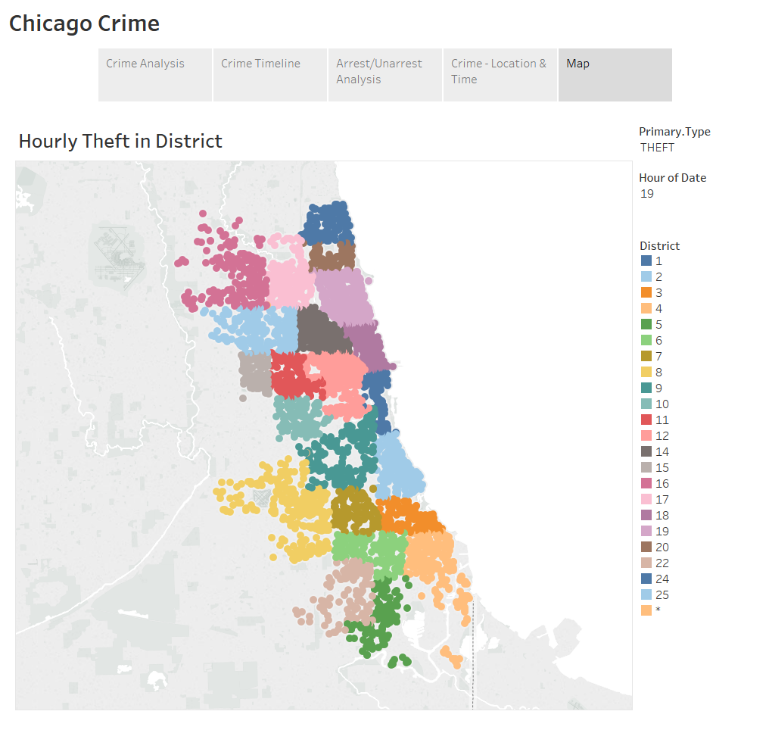

* Maps show theft count district wise in Chicago city at 1900 Hrs.

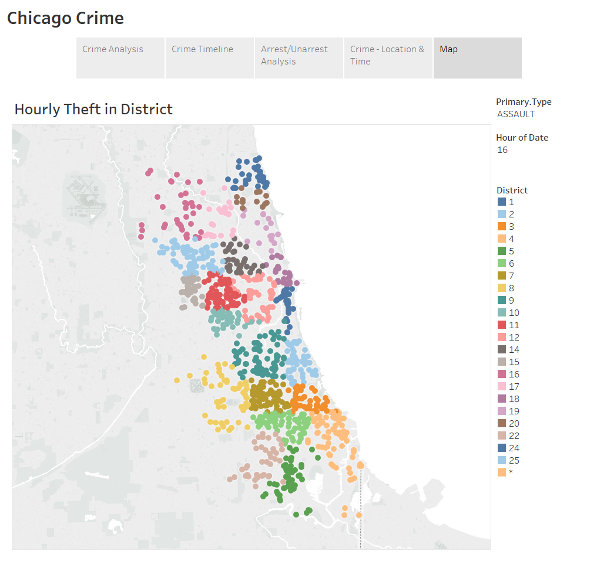

* Maps show assault count district wise in Chicago city at 1600 Hrs.

Chicago Crime

Leaflet (maps)



* **This is the overall number of crimes in the Chicago city**



* **When you go on zooming you can reach to the actual location where the crime happened with its specific details.**

**Following are the results of Predictive Analysis :-**

* **Multinomial Logistic regression: -**



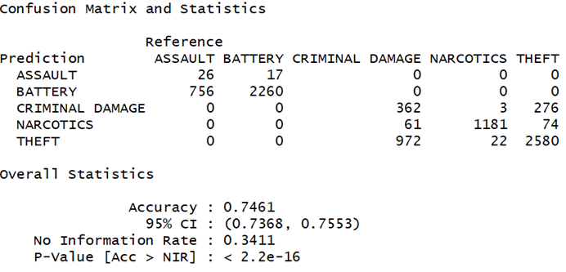

* **Random Forest**

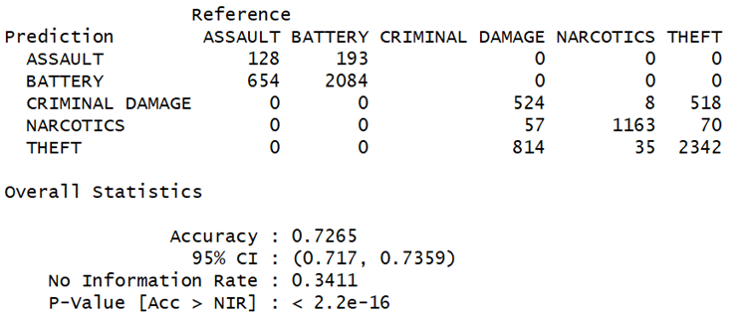

* **SVM**

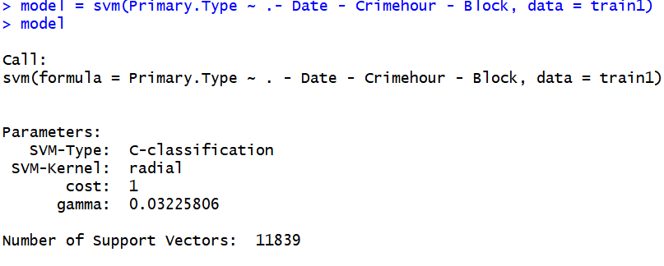

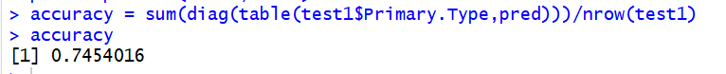

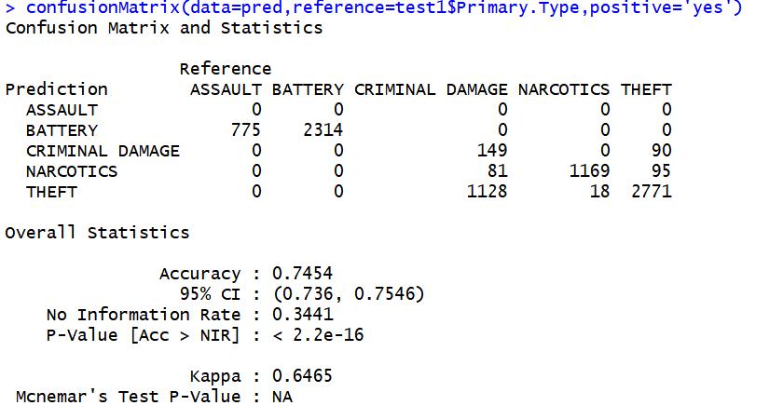

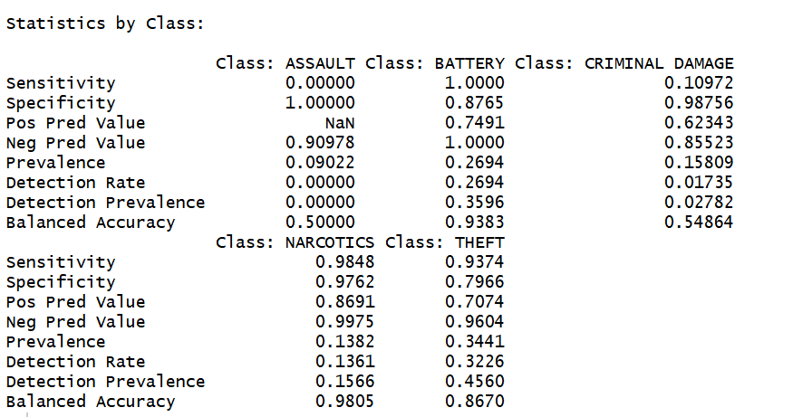

DISCUSSION

* From the interactive spatial plots, we see that residential areas were the highly crime prone areas.
* The temporal analysis showed most crimes happening between spring and fall every year.
* The above results would help the local public who wish to transfer to different areas in the city or to be cautious when they are out on the roads.
* Based on the experimental results, multinomial logistic regression model performed well in prediction. The proposed model finds its use in law enforcement department to deploy more police forces in highly crime prone areas.

**LIMITATIONS**

* Data imbalance issue is present since there were more records for theft than any other crime types.
* Influences of crimes based on the presence of beat in that location.
* Not able to generate heat maps on geospatial map as google api’s were removed.

**FUTURE SCOPE**

* Use stratified sampling and feature selection to get better models for predicting crime type.
* Include demographic data and use age group to find better crime patterns
* Perform k-means clustering to find natural groupings of crime locations.
* Detailed analysis on why arrest rates are decreasing over the years.

**BUSINESS OBJECTIVE ACCOMPLISHED**

1. The non-violence crimes are decreasing over the years but the same is not the case for violence crimes
2. Serious Offenses crimes are more as compared to other crimes
3. Most crimes take place at Residential and Pathways
4. Most theft crimes take place at 6 pm in the evening and less at 5 in the morning
5. The number of arrest are very less over the years

**REFERENCES**

* ***<https://trendct.org/2015/06/26/tutorial-how-to-put-dots-on-a-leaflet-map-with-r/>***

* ***<https://nycdatascience.com/blog/student-works/r-shiny/analysis-and-visualization-of-crime-in-chicago/>***

* ***<https://www.rdocumentation.org/packages/leaflet/versions/2.0.2/topics/leaflet>***